Hypertension and Prescriptions

NHANES EDA

Ethan Bard

Florida Polytechnic University

| Prevalence of Hypertensive Drug Categories 2013-2018 | |
| --- | --- |
|  | |
| Drug Category | Count |
| ACE | 1627 |
| CCB | 1342 |
| BB | 1326 |
| Combination | 906 |
| ARB | 879 |
| other | 662 |
| diuretic | 508 |

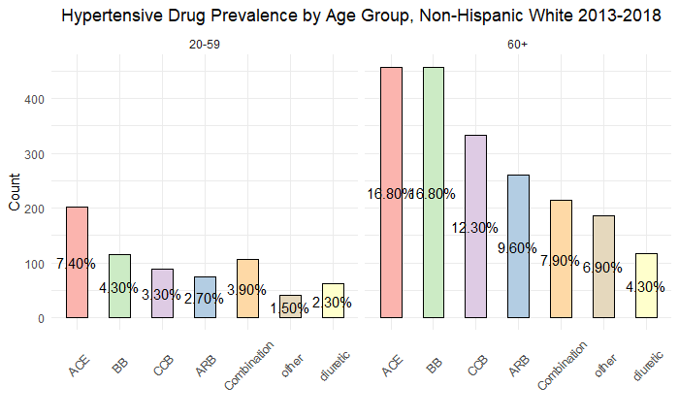

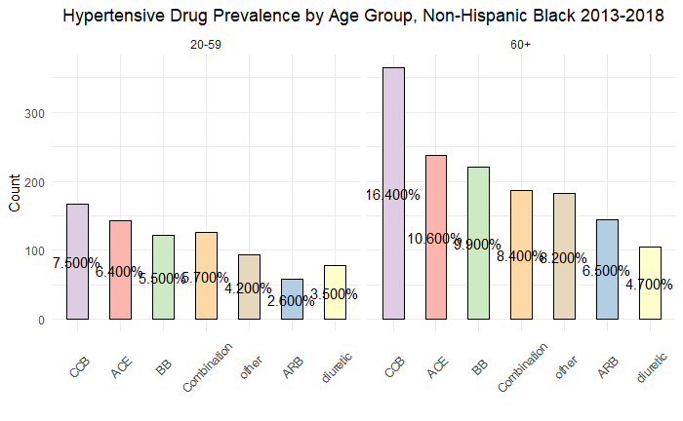

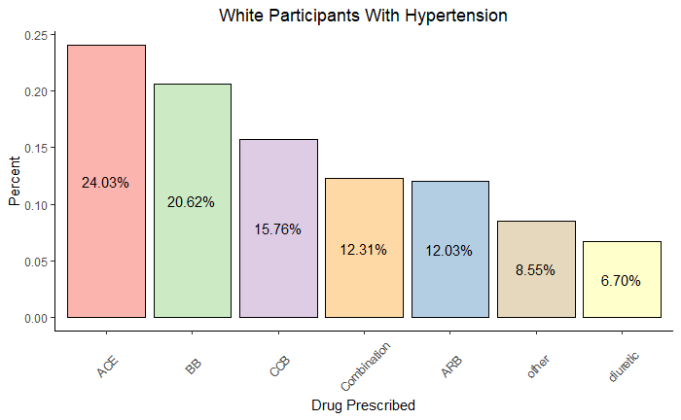

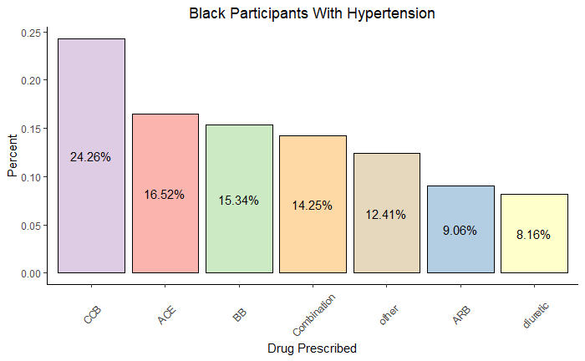

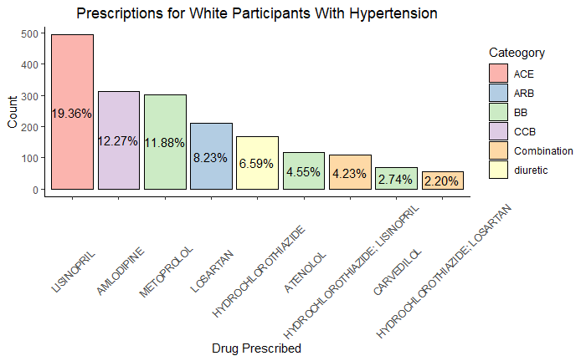

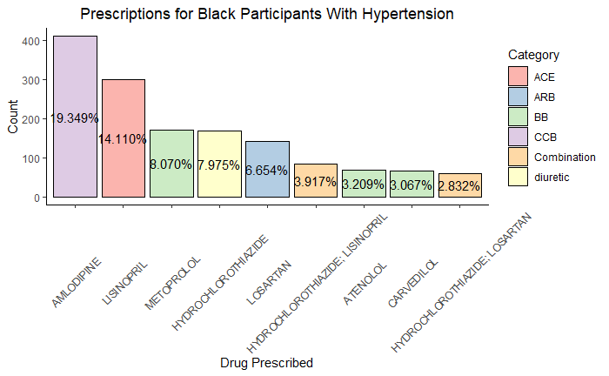

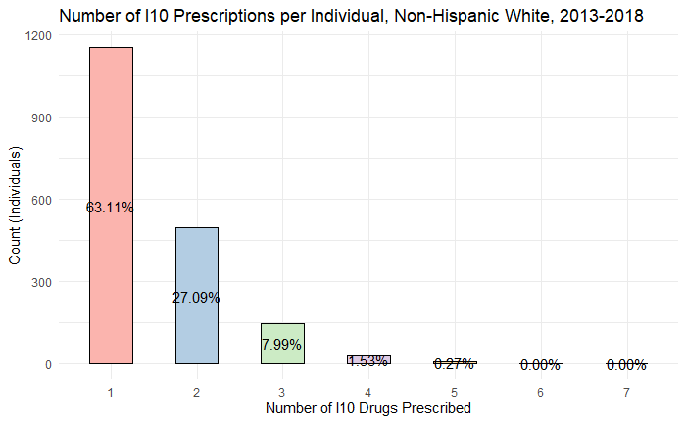

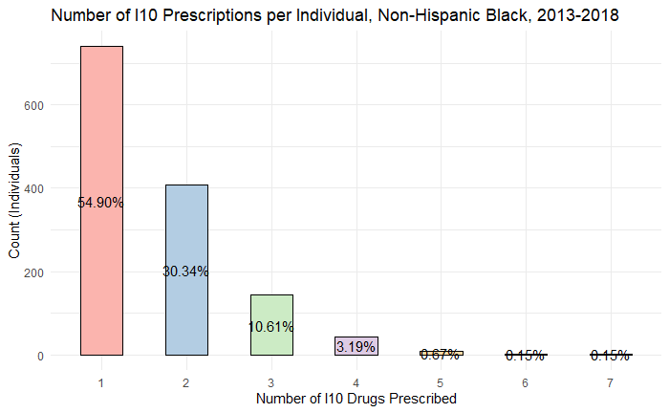

**Appendix – Tables**

| **Hypertensive Drug Prevalence Non-Hispanic White 2013-2018** | | | |
| --- | --- | --- | --- |
| **N = 2718** | | | |
| Age Group | Drug | Count | percent |
| 60+ | ACE | 457 | 16.814% |
| 60+ | BB | 457 | 16.814% |
| 60+ | CCB | 333 | 12.252% |
| 60+ | ARB | 260 | 9.566% |
| 60+ | Combination | 215 | 7.910% |
| 20-59 | ACE | 202 | 7.432% |
| 60+ | other | 187 | 6.880% |
| 60+ | diuretic | 117 | 4.305% |
| 20-59 | BB | 116 | 4.268% |
| 20-59 | Combination | 107 | 3.937% |
| 20-59 | CCB | 89 | 3.274% |
| 20-59 | ARB | 74 | 2.723% |
| 20-59 | diuretic | 63 | 2.318% |
| 20-59 | other | 41 | 1.508% |

| **Hypertensive Drug Prevalence Non-Hispanic Black 2013-2018** | | | |
| --- | --- | --- | --- |
| **N = 2230** | | | |
| Age Group | Drug | Count | percent |
| 60+ | CCB | 365 | 16.368% |
| 60+ | ACE | 237 | 10.628% |
| 60+ | BB | 221 | 9.910% |
| 60+ | Combination | 187 | 8.386% |
| 60+ | other | 183 | 8.206% |
| 20-59 | CCB | 167 | 7.489% |
| 60+ | ARB | 144 | 6.457% |
| 20-59 | ACE | 143 | 6.413% |
| 20-59 | Combination | 126 | 5.650% |
| 20-59 | BB | 122 | 5.471% |
| 60+ | diuretic | 105 | 4.709% |
| 20-59 | other | 94 | 4.215% |
| 20-59 | diuretic | 78 | 3.498% |
| 20-59 | ARB | 58 | 2.601% |

| **Number of I10 Prescriptions per Individual, 2013-2018** | | | | |
| --- | --- | --- | --- | --- |
| **Number of Prescriptions** | **Non-Hispanic White**  **N = 1827** | | **Non-Hispanic Black**  **N = 1348** | |
| 1 | 1153 | 63.109% | 740 | 54.896% |
| 2 | 495 | 27.094% | 409 | 30.341% |
| 3 | 146 | 7.991% | 143 | 10.608% |
| 4 | 28 | 1.533% | 43 | 3.190% |
| 5 | 5 | 0.274% | 9 | 0.668% |
| 6 | 0 | 0.000% | 2 | 0.148% |
| 7 | 0 | 0.000% | 2 | 0.148% |